**1. INTRODUCTION TO HTML**

HTML (HyperText Markup Language) is the standard language used to create the structure of web pages.  
It defines the content of a webpage — headings, paragraphs, images, links, tables, and forms.  
Every HTML document has a .html extension.

**Structure of an HTML Page**

<!DOCTYPE html>

<html lang="en">

<head>

<meta charset="UTF-8">

<meta name="viewport" content="width=device-width, initial-scale=1.0">

<title>My First Web Page</title>

</head>

<body>

<h1>Welcome to HTML Basics</h1>

<p>This is my first HTML web page.</p>

</body>

</html>

**Explanation:**

* <!DOCTYPE html> – defines the document type (HTML5)
* <html> – root tag for all HTML content
* <head> – contains metadata like title and stylesheet links
* <body> – contains visible content that appears in the browser

**2. HTML ELEMENTS & ATTRIBUTES**

**Elements** are building blocks of HTML (e.g., <p>, <h1>, <img>, <table>).  
**Attributes** provide additional information to elements (e.g., src, href, class, id).

Example:

<a href="https://example.com" target="_blank">Visit Example</a>

* href = URL link
* target="_blank" = opens the link in a new tab

**3. HEADINGS, PARAGRAPHS, AND LISTS**

* **Headings:** <h1> to <h6> define title hierarchy.
* **Paragraphs:** <p> defines text blocks.
* **Lists:**
  + Ordered List: <ol> for numbered lists
  + Unordered List: <ul> for bullet lists
  + List Items: <li> represents each item

Example:

<h2>Course Topics</h2>

<ol>

<li>HTML Basics</li>

<li>CSS Design</li>

<li>JavaScript Programming</li>

</ol>

**4. LINKS & IMAGES**

**Links:**

<a href="https://www.google.com">Go to Google</a>

**Images:**

<img src="photo.jpg" alt="My Photo" width="200" height="200">

* src = image path
* alt = alternate text (for accessibility)

**5. HTML Tables**

Tables are used to display data in rows and columns.

Example:

<table border="1">

<tr>

<th>Student Name</th>

<th>Course</th>

<th>Marks</th>

</tr>

<tr>

<td>Udaya Kumar</td>

<td>.NET</td>

<td>90</td>

</tr>

<tr>

<td>Rahul</td>

<td>Java</td>

<td>85</td>

</tr>

</table>

**Key Tags:**

* <table> → table container
* <tr> → table row
* <th> → table header cell
* <td> → table data cell

**6. HTML FORMS**

Forms are used to collect user input, such as login, registration, or data entry.

Example:

<form action="/submit" method="POST">

<label for="name">Name:</label>

<input type="text" id="name" name="username" required><br><br>

<label for="email">Email:</label>

<input type="email" id="email" name="useremail"><br><br>

<label for="course">Course:</label>

<select id="course" name="course">

<option>.NET</option>

<option>Java</option>

<option>Python</option>

</select><br><br>

<input type="submit" value="Submit">

</form>

**Explanation:**

* <form> defines the input area
* action specifies the URL where data is submitted
* method specifies HTTP method (GET or POST)
* required ensures mandatory fields

**7. SEMANTIC HTML (HTML5 ELEMENTS)**

Semantic elements describe their purpose, making code more meaningful and SEO friendly.

Examples:

* <header> – top section of the page
* <nav> – navigation bar
* <section> – group of related content
* <article> – independent content block
* <footer> – bottom of the page

Example:

<header>

<h1>Dhruv Compusoft Portal</h1>

</header>

<nav>

<a href="#home">Home</a> | <a href="#about">About</a> | <a href="#contact">Contact</a>

</nav>

<section>

<h2>About Us</h2>

<p>We are a software development company.</p>

</section>

<footer>

<p>&copy; 2025 Dhruv Compusoft</p>

</footer>

**8. BEST PRACTICES**

* Always close tags properly.
* Use lowercase tag names.
* Include alt for all images.
* Indent code for readability.
* Use semantic tags whenever possible.
* Validate your HTML using W3C Validator (<https://validator.w3.org/>).

**Mini Practice Task (Day 1)**

Create a **Student Registration Page** using:

* HTML form (name, email, course)
* Table for student list
* Semantic layout (header, section, footer)

**Snapshots :**

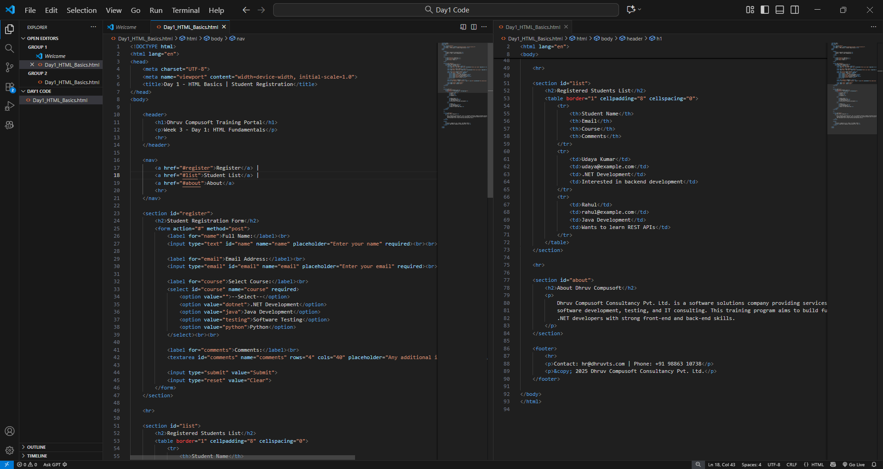

Code File : Day1_HTML_Basics.html

Output : Day1_HTML_Basics.html